**PRACTICAL -11**

**Aim – selection sorting.**

**Code –**

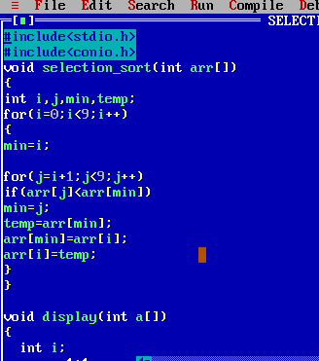

**Code –**

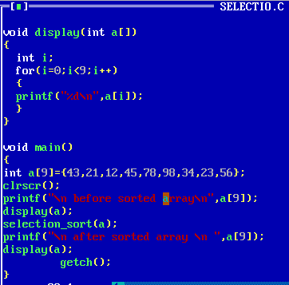

**Output –**

